1. **SCOPE**

The specific purpose for this Work Instruction is to provide details on the features of the data analysis section of the MWQM CSSP Web Tools.

1. **REFERENCES**

CSSP Web Tools at this address: <http://wmon01dtchlebl2/>

1. **PROCEDURE**

3.1. Open CSSP Web Tools at this address: <http://wmon01dtchlebl2/>

3.2 Click on: ‘[Latest CSSP Web Tools](http://wmon01dtchlebl2/csspwebtools/)’

3.3 Click on: Start Using CSSP Web Tools. If you were not logged on previously you will have to log in. Click on ‘Log in ’, Enter your email and password and then click on ‘Start Using CSSP Web Tools’

3.4 Navigate to the desire subsector and select the MWQM Sites tab.

3.5 Click on the ‘analysis button’ to access the data analysis section. The page may take longer to load if there is a lot of data for the particular subsector you are working with. The data analysis section will look like (see page2). To make navigating through the data easier and quicker, here are a few tips:

* Reduce text size to be able to view more table columns and rows
  + Internet Explorer: Ctrl + wheel OR Ctrl + ‘+++’ or ‘- - -‘ to reduce
  + Chrome: Ctrl + wheel
  + Firefox: Ctrl + wheel
* Scrolling down
  + Internet Explorer: wheel or arrows or page up/down or spacebar
  + Chrome: wheel or arrows or page up/down or spacebar
  + Firefox: wheel or arrows or page up/down or spacebar
* Scrolling horizontally
  + Internet Explorer: Ctrl + Shift + wheel or left or right arrows
  + Chrome: Shift + wheel or left or right arrows
  + Firefox: left or right arrows

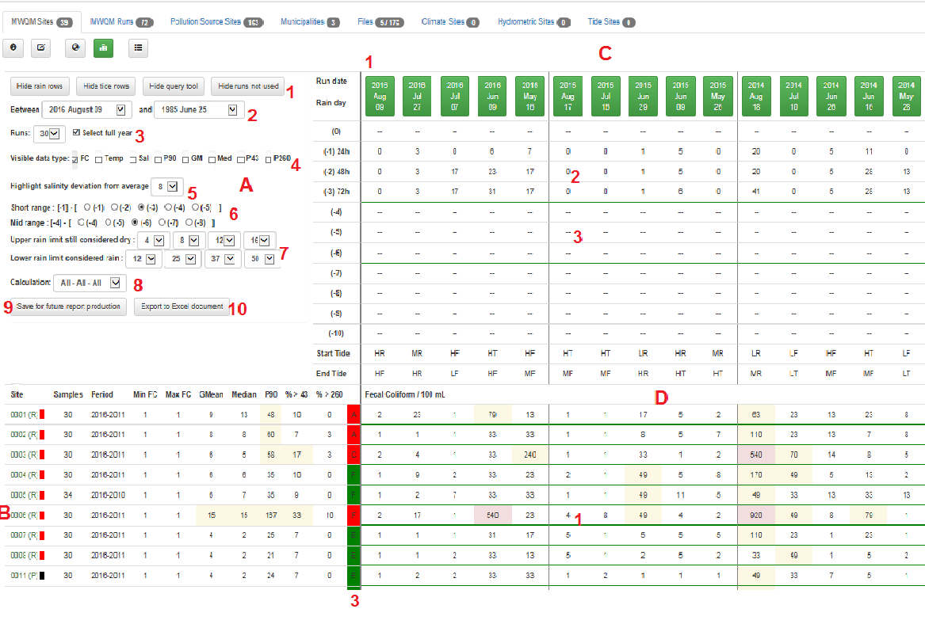

3.6 The data analysis section combines both the raw data and the visuals to help the user with quick analysis.

3.6.1 Section A

This section is used to dynamically set the parameters for which the statistics will be calculated. Various parameters can be set to change the statistical calculation or the viewing of the raw data.

* A1 – Allows you to hide specific sections of the tables
* A2 – (Between) list all subsector runs starting with latest run. It determines the latest run you want to include in the calculation. All runs after this date will not be considered.

– (and) list all subsector runs starting with latest run. It determines the earliest run you want to include in the calculation. All runs before this data will not be considered.

* A3 – (Runs) list the number of runs starting at 10 to total number of runs. It determines the maximum number of runs to use for the calculations. The ‘Select full year’ check box when checked makes sure that years aren’t split up when doing the calculations.
* A4 – (Visible data type) list available data type available to view as raw or calculated which is shown in section D. Available options are:
  + Fecal Coliform / 100 mL
    - Coloring (background): yellow > 43 --- red > 500
  + Temperature
    - Coloring (background): none
  + Salinity
    - Coloring: underlined red (site average + 8) or (site average – 8)
  + P90
    - Coloring: underlined red > 43
  + Geometric Mean
    - Coloring: underlined red > 14
  + Median
    - Coloring: underlined red > 14
  + % of P90 > 43
    - Coloring: underlined red > 10%
  + % of P90 > 260
    - Coloring: underlined red > 10%
* A5 – (Highlight salinity deviation from average) – can change the default setting for salinity highlight feature discussed at A4.
* A6 – (Short range, Mid-range) changes the green visual line C2 and C3. Does not change any calculations but changes what is considered rain in the ‘short range’ and ‘mid range’
* A7 – (upper rain and lower rain limits) indicate the lower limit for which the run will be identified as a dry run and a rain run.
* A8 – (Calculation) list 7 options (???). In order for this to word properly you must set the rain limits (A7 – 24h, A8 – 48h, A9 – 72h). The minimum requirement is one of these rain limits.
* A9 – (Save for Report button) this button will save the existing parameters (actually only the rain limits (24h, 48h and 72h) and the runs which would have been clearly identified not to be used (section C, red indicator (top button)).
* A10 – (Export to Excel document)

3.6.2 Section B

This section indicates various useful statistics results and visuals to help the user make a decision on the status of a particular classification of the subsector. Note: ‘--‘ indicates no calculation or value is available.

* B1 – indicate the monitoring site name followed by the site latest classification and a visual coloring for quick reference.
  + A – approved – green
  + CA – conditionally approved --- green
  + R – restricted --- red
  + CR – conditionally restricted --- red
  + P – Prohibited --- black
  + U – Unclassified --- white
* B2 – indicate the statistic result
  + Samples – number of samples used for the monitoring site and period
  + Period – start and end years use for statistical calculation
  + Min FC – minimum FC for the monitoring site and period
  + Max FC – maximum FC for the monitoring site and period
  + GMean – geometric mean for the monitoring site and period
  + Median – median for the monitoring site and period
  + P90 – P90 for the monitoring site and period
  + % > 43 – Percent of P90 > 43 for the monitoring site and period
  + % > 260 – Percent of P90 > 260 for the monitoring site and period
* B3 – Purple, red, green and blue with a letter or number – these represent the actual level of classification (indicator similar to map) resulted from the newly calculated statistics
  + Letter (A to F --- better to worse)
  + Number – number of samples
  + Purple – no depuration
  + Red – fail
  + Green – pass
  + Blue – not enough data

3.6.3 Section C

This section indicates if the run is used for the statistical calculation, the rain 24h, 48h, 72h (up to 10 days) previous to the run as well as the tide information. Note: “—“ indicates no calculation or value is available.

* C1 – (Row 1) – buttons showing the date of the run. Clicking on a green or blue button will changed the color of the button to red (omitting it from statistical calculation). Clicking on a red button will convert it back to its normal state making it available to be used for statistical calculation. Various coloring are use:
  + Green – use in statistical calculation
  + Red – omitted from statistical calculation
  + Blue – indicate a rain run --- will be use when calculation drop down selected “include rain” and “only rain” and will not be selected when calculation drop down selected “no rain”.
  + Grey – indicate the runs not use for statistical calculation
* C2 – indicate rain for 24h, 48h, 72h and up to 10 days prior to run
  + Blue – indicate the run to be a rain run
  + No coloring – indicate the run is not identified as a rain run
* C3 – indicate the tide information during the run

3.6.3 Section D

This section indicates raw data as well as calculated statistics for each monitoring site and runs. Note: “- -“ indicates no calculation or value is available. The Visible data type check boxes should be used to change the data type being viewed.

* Available data type which can be display in section D are:
  + Fecal Coliform / 100 mL
    - Coloring (background): yellow > 43 --- red > 500
  + Temperature
    - Coloring (background): none
  + Salinity
    - Coloring: underlined red (site average + 8) or (site average – 8)
  + P90
    - Coloring: underlined red > 43
  + Geometric Mean
    - Coloring: underlined red > 14
  + Median
    - Coloring: underlined red > 14
  + % of P90 > 43
    - Coloring: underlined red > 10%
  + % of P90 > 260
    - Coloring: underlined red > 10%

1. **MAINTENANCE**

For any additional troubleshooting help (errors or bugs), please contact Charles LeBlanc (Charles.leblanc@ec.gc.ca). For general questions, contact your local CSSP working group committee member.